 |  | 
 | Blackberry 8110 pear
 | 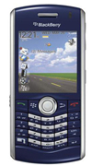 | Description  The BlackBerry Pearl 8110 smartphone is designed to help you do everything you want with your life1. It comes complete with advanced phone features, multimedia, digital camera, video recording, built-in GPS1 and expandable memory.  STORE PRICE: Rs 24,028 /-  ONLINE PRICE: Rs 22,836 /-
Brand : Blackberry
Model Name : 8110
Released Year : 2008
Phone Memory : 64 MB
External Memory : microSD(TransFlash)
Colors : Black and blue
Form : Bar
Dimensions : 107 x 50 x 14 mm
Weight : 91g

